1) Create a S3 bucket, with no public access and upload files to the bucket

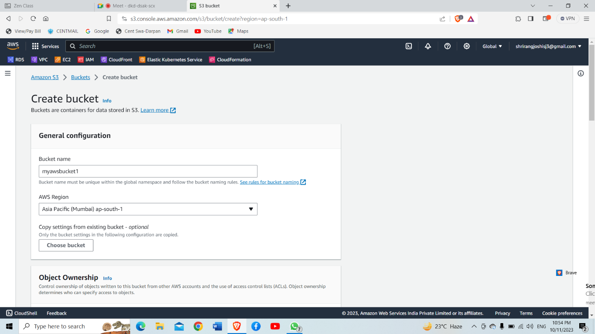

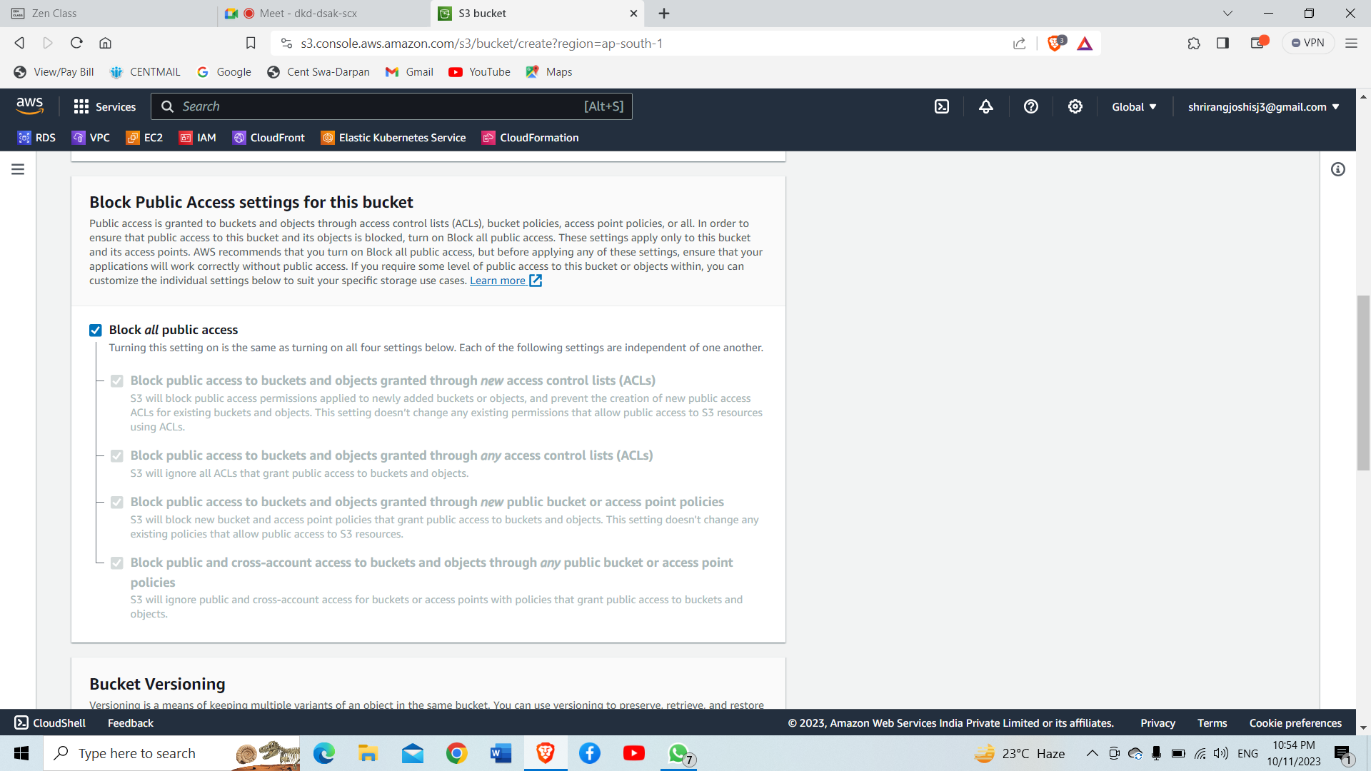

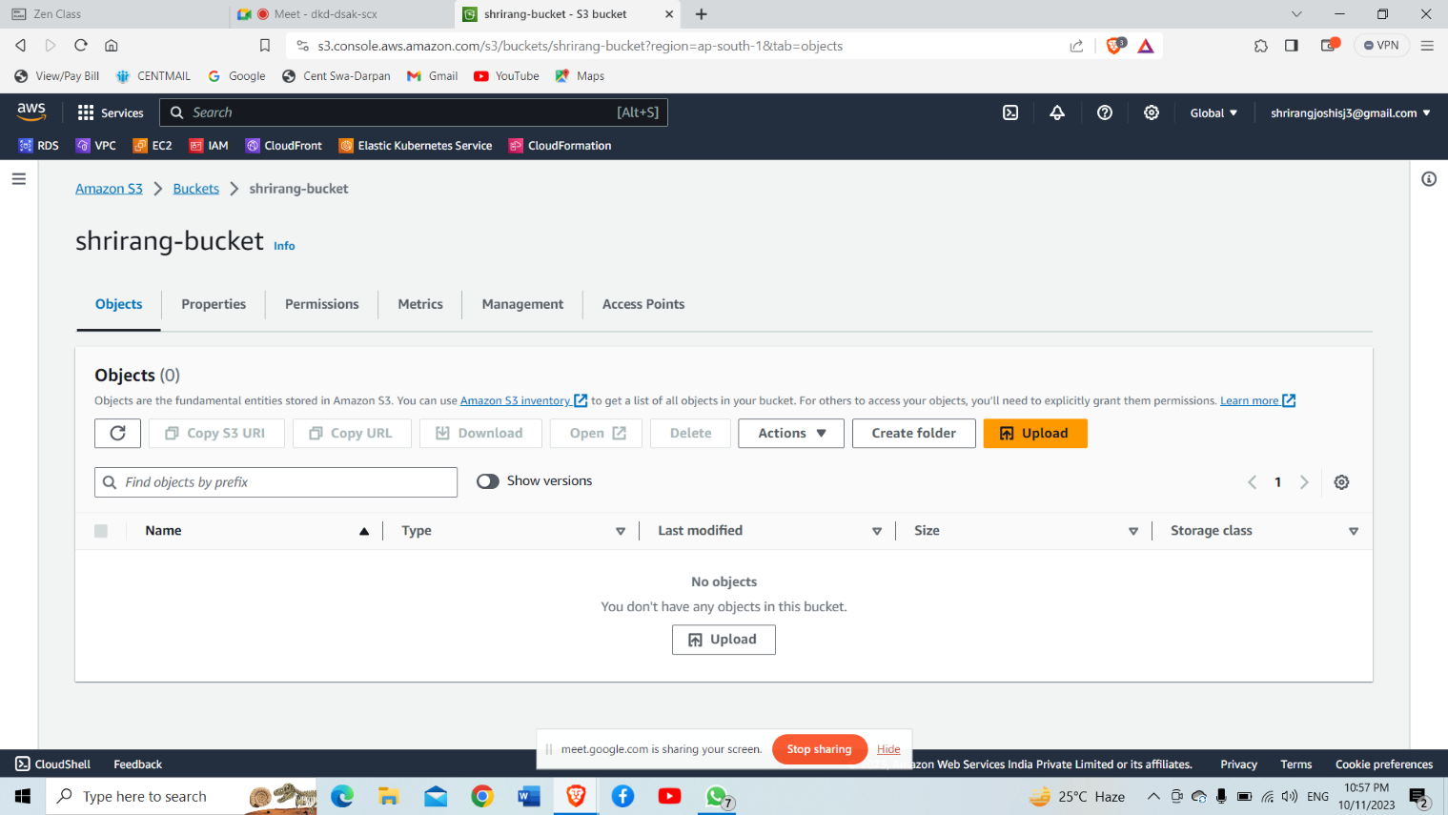

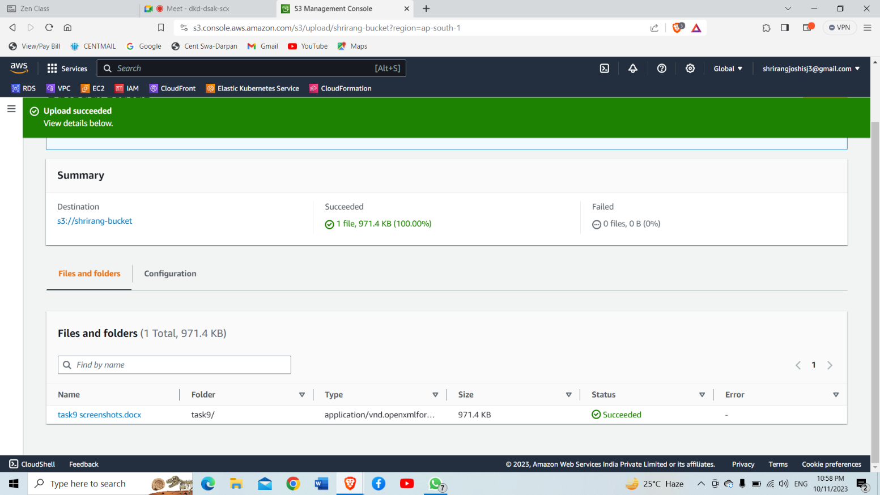

2) Launch two ec2-instances and connect it to a application load balancer, where the output traffic from the server must be an load balancer IP address

